БЪЛГАРСКИ ЕНЕРГИЕН И МИНЕН ФОРУМ
BULGARIAN ENERGY& MINING FORUM

БЪЛГАРСКИ ЕНЕРГИЕН ФОРУМ



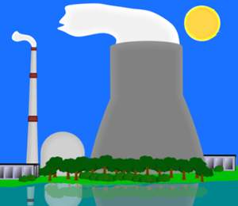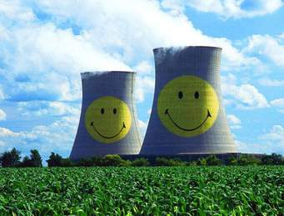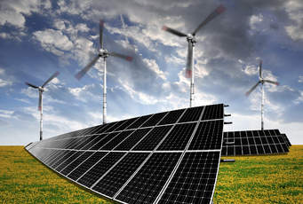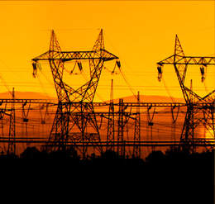
INVITATION
for participation in

8th Regional Energy Conference
Today’s Agenda of The Regional Energy Development –
Priorities, Technologies, Markets
17 May 2019, Grand Hotel Balkan, Sofia, Bulgaria

Under the patronage of the Minister of Energy of Bulgaria
Mrs. TemenuzhkaPetkova

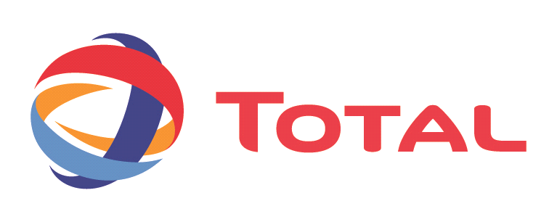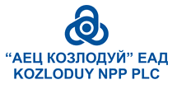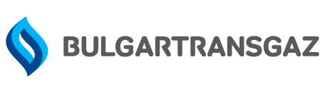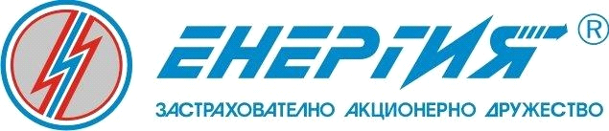
Sponsors

Goals
The conference will bring together senior representatives from the EU country members state administrations, European institutions and NGOs, electricity and gas traders and suppliers, developers of new technologies and equipment suppliers, policy regulators and industry associations, market analysts and consultants, research organizations and institutes, distributions network and transmission service operators, financial investments companies and governmental representatives.
The event will provide excellent opportunities to learn from high profile speakers sharing their knowledge and experience on overcoming the current challenges to managing new energy development projects and services.
You will also have the chance to network with high level managers of power companies and industry leaders from across the entire value chain, to maximize the opportunities arising in the energy production and supply market, whilst also discovering the latest technologies and solutions that facilitate the regional energy development.
The program Committee intend to introduce new approach for Conference carrying out where for each of the four panels key speakers will give general view of the problems related to the topic. Following this, the panelists will provide some specific ads to the presented overview in order to support the discussions by emphasizing some details and to stimulate the contribution from the attendees.
You are kindly invited to the traditional Regional Energy Conference of BEMF of the year to discover the key topics and updates from the latest developments in the essential areas of the energy development.
The working languages of the Conference are Bulgarian and English, with simultaneous translation.

Ivan Hinovski,
Conference Program Director

Draft Program
8:30-9:00 Registration and welcome coffee
09:00 – 09:30 Official opening and welcomes

MarosSevcovic, European Commissioner for Digital Economy and Society - video
Temenuzhka Petkova, Minister of Energy

09:30–10:45:
Panel 1: Coal regions in transition: time for decisions
Moderator: Krassen Stanchev, Institute for Market Economy
Introducing paper:Julian Popov, European Climate Foundation/BPIE, The transition model for Maritza East Energy Complex and successful criteria
Panelists:
Estathios Peteves, JRC, The perspectives for coal regions development in EU
Olivier Marquette,AES
Brian Rickets, President of EUROCOAL
Representative of PPC, Greece
Shteriu Shterev, Scientific Technical Union “Mining & Geology”, Bulgaria, Ways to go ahead with Bulgarian coal industry
Discussion

10:45 – 11:15: Coffee break

11:15–12:30:
Panel 2: Competitive renewables without subsidies: Is this attainable?
Moderator: Angela Toneva, Energo Pro
Introducing paper:GorbuzGonul, IRENA, The potential of the renewable energy generators competitiveness
Panelists:
Matthias Buck, Agora Energiewende, Ways to decrease the price of the capital for renewable energy
Kostadin Sirleshtov,CMS CMCK, Corporate PPA and their impact on the green energy marketdevelopment
Dian Chervenkondev, Bulgaria, Bulgarian energy security fund and its operation in the new regulatory environment
Prof. HristoVassilev, Technical University of Sofia, State-on-the art of the green energy production and their potential share in power generation in Bulgaria;
Evgenia Haritonova, Bulgarian Energy Regulatory Commission, Policy and regulatory changes needed for adoption and integration of energy storage facilities
Discussion

12:30–13:15: Lunch break

13:15–14:30:
Panel 3: Regional market of electricity and gas: driving forces and barriers
Moderator: Krassimir Dachev, Sviloza AD
Introducing papers: Invited speaker from ACER
Presentation of TOTAL
Panelists:
Vladimir Malinov, Bulgargas, Updates of Bulgarian energy strategy related to natural gas supply and market development
Ass.professor Ivan Ivanov, Chairman of Bulgarian Energy Regulatory Commission, Status and perspectives of establishment of regional energy market
Shell, Establishment of functional deregulated wholesale gas market: policy and regulatory changes ahead
Konstantin Konstantinov, IBEX
Victor Grigorescu, Romania: Possibilities and roadmap for regional energy and natural gas market integration ?
Discussion

14:30 – 15:00: Coffee break

15:00 – 16:30:
Panel 4: Nеw nuclear build on deregulated energy markets: affordable projects
Moderator: Daniela Bobeva, BAS
Invited key speaker: Anton Ivanov, BEMF, Applicable business models for new nuclear builds on deregulated energy markets – world practice and local specificity
Panelists:
EURATOM: Nuclear fuel and diversification of supplies
Vadim Titov, ROSATOM&TVEL, Russia: Market solutions for new EU customers
CNNC, China: Development of new nuclear plant in Bulgaria-options and conditions
Discussion

16:30 – 18:00:
Panel 5:Innovations in power industry and electromobility
Мoderator:IlianVassilev, Innovative Energy Solutions, Ltd.
Presentations:
IchkoRachev, „Nelbo Engineering“,Dimitar Dimitrov„Аttractsoft“GMBh, Alexander Vassilev„А1”,Приложение на IoTтехнологията: Интегриранаинформационна система на мобилния оператор A1 за индивидуален контрол и разплащания базирана на платформатаSALIRO
Ivan Kostov, Electromobilityand energy transition in Bulgaria
Lubomir Dimitrov,Circular energy: innovative technology for ecological and low-emissions power generation from wastes
Dr.Rolf Schiffer, Germany,The potential contribution of geothermal potential of Sofia region for the energy and power balance of Bulgarian electrical grid and emissions reduction.
Plamen Grancharov, Power Max, Bulgariaя,The advanced Bulgarian projects for production of Ni-Zn accumulators for energy storage
Delian Petrov, State Enterprise for Radioactive Waste Treatment (SERAWT), Bulgaria,The experience of plasma burning of RAW facility in SERAWT

18:00 – 18:30 Final discussions, closing remarks and official closure of the Conference

18:30 Reception

The BULGARIAN ENERGY & MINING FORUM ® is a non-governmental organization, with membership comprising legal and physical entities with expertise in national and international energy development. The Association is a wide publicly based forum that welcomes participation from power producers and consumers, academic, environmental and other non-governmental organizations, experts and professionals from various government departments and institutions, private and public industry companies, associations of capital, industry and trade union organizations, representatives of the media and intellectuals.
http://bulenergyforum.org

Bulgarian Energy & Mining Forum
1000 Sofia,Bulgaria 4 Trapezitsa Str., floor 4
Phone:/Fax: +359 2/98 98 950, Mobile +359 888 522 776
E-mail: bulenergo@gmail.com, office@bulenergo.com

